**CO322 - LAB 08**

**GRAPHS**

WIJERATHNE E.S.G.

E/18/397

SEMESTER 05

22/01/2023

**Task 1**

Code

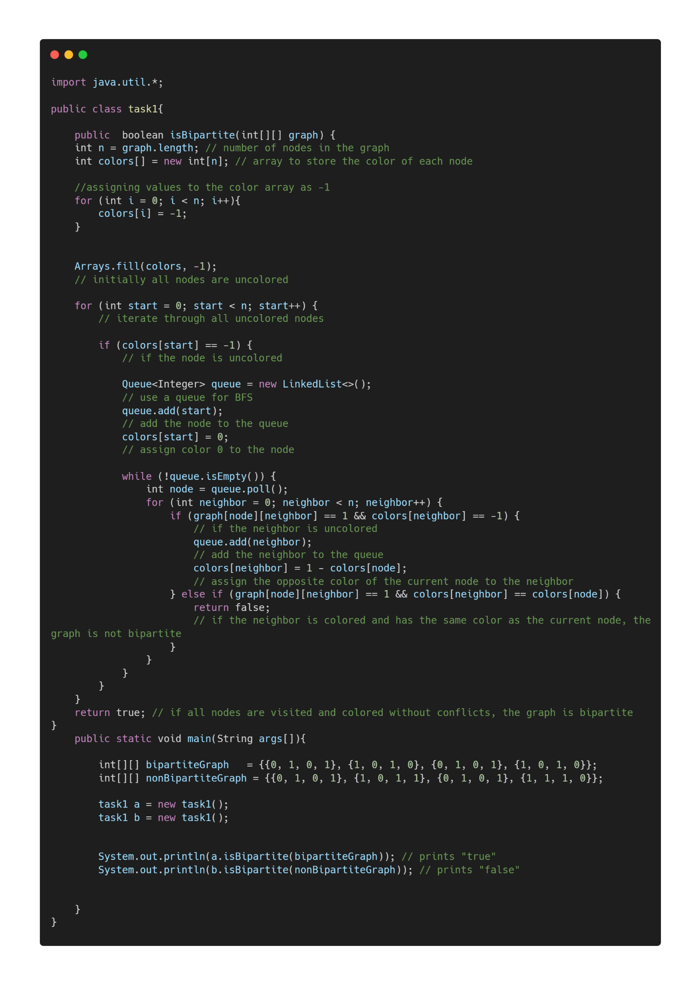

Output

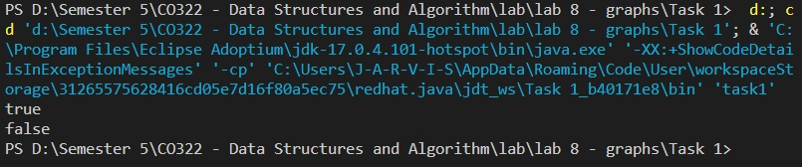

**Task 2**

Code

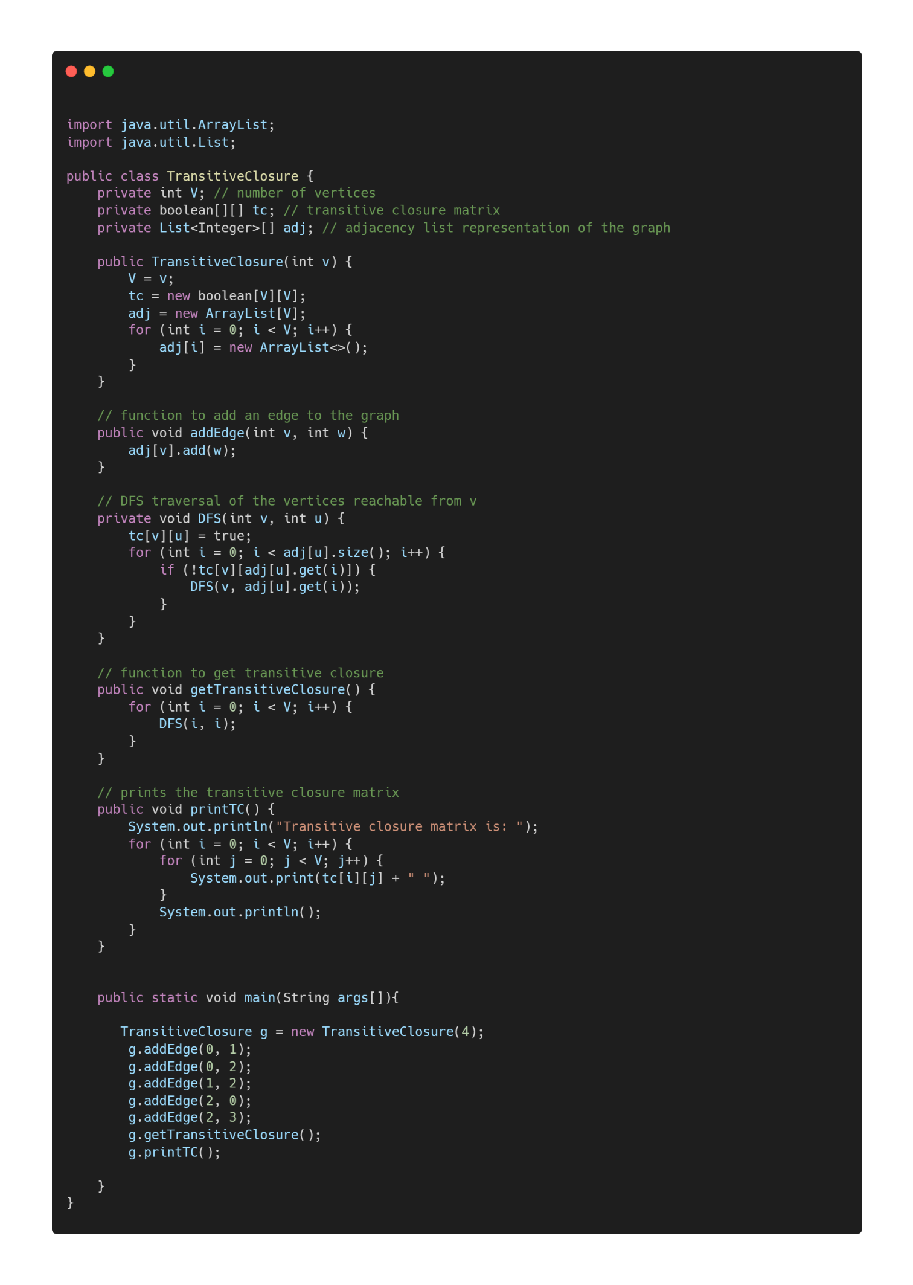

Output

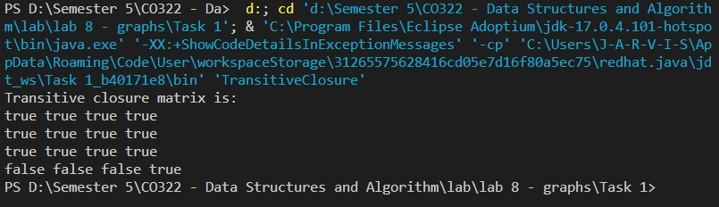

**Task 3**

Code

Node class

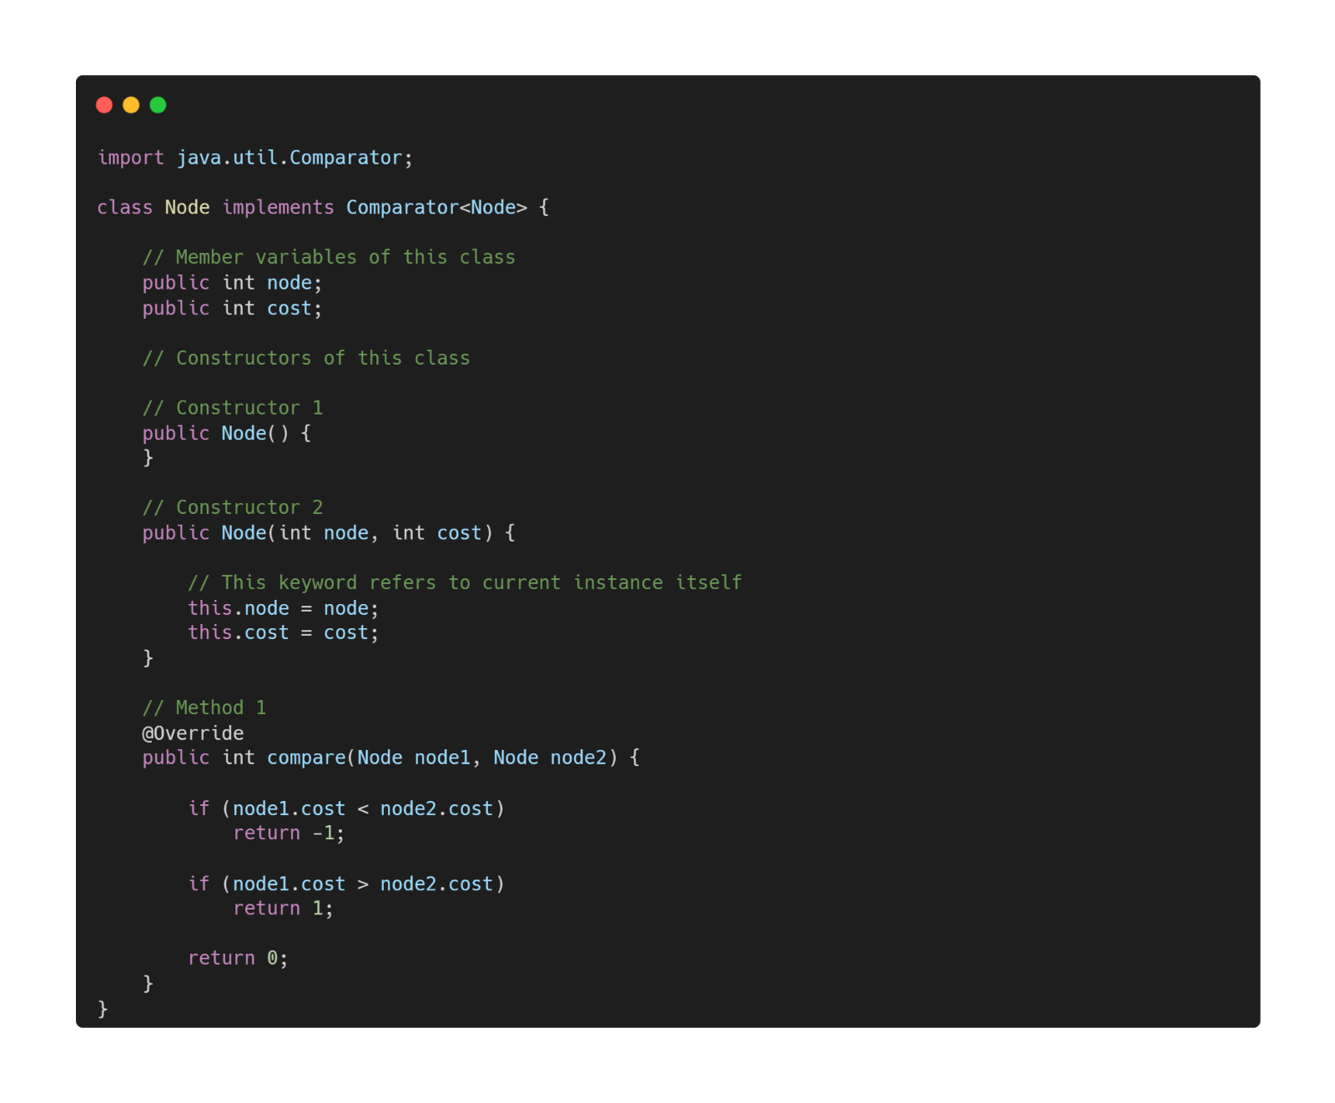

Task 3 Algorithm

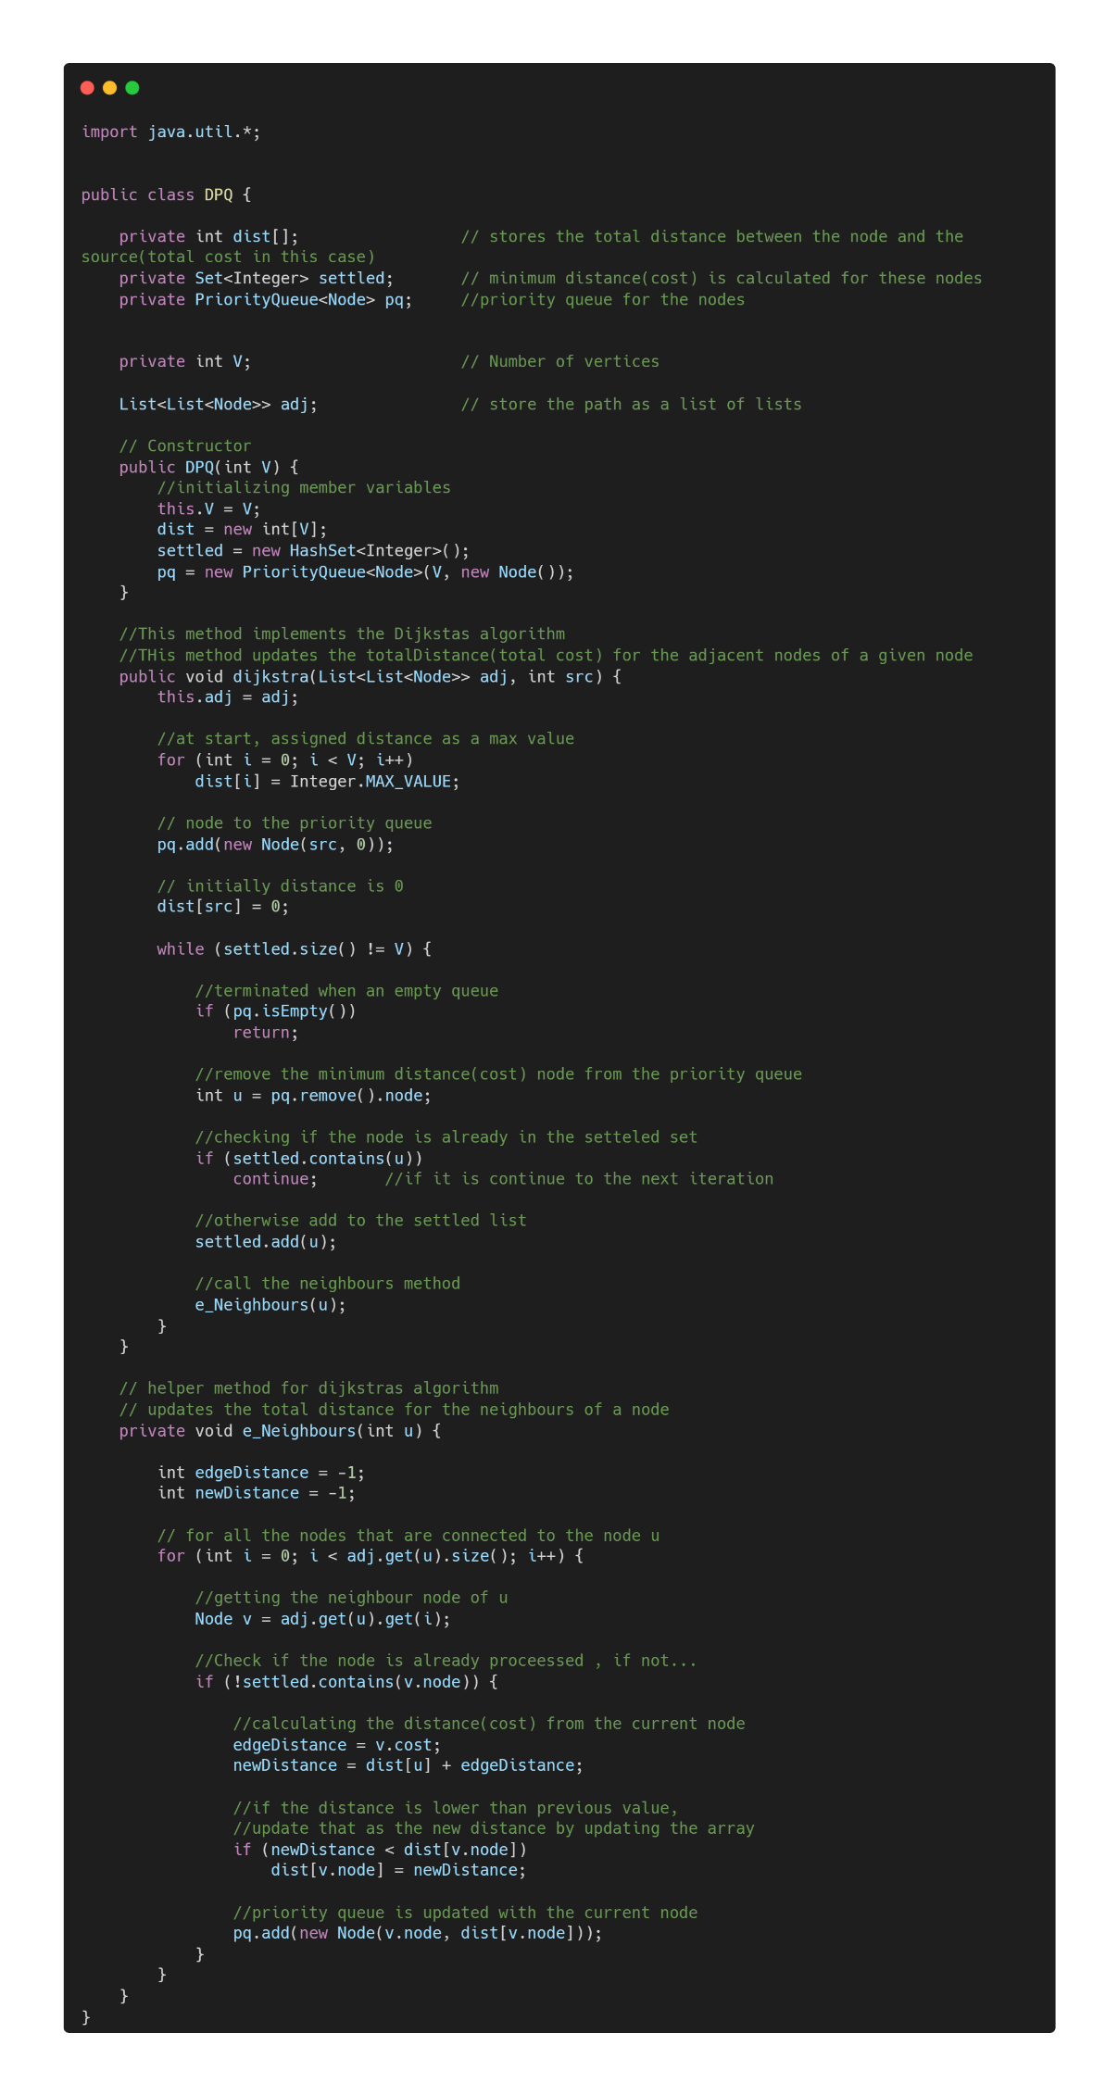

Main part to check the code.

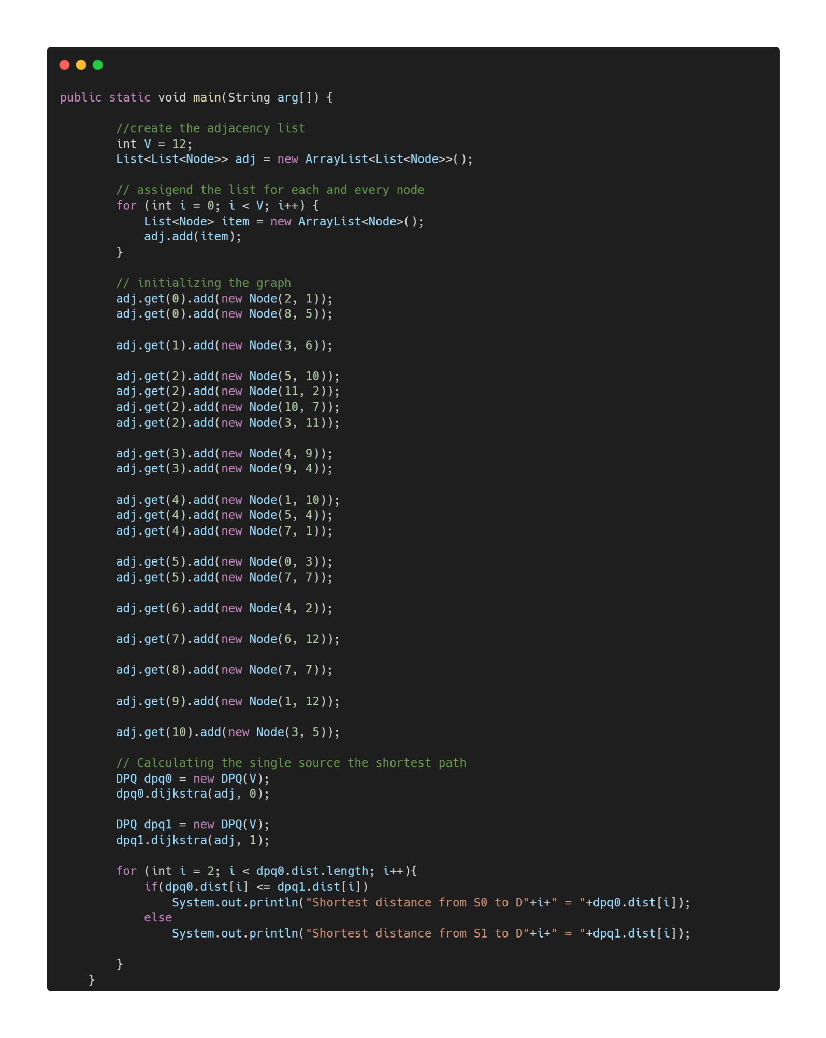

Output

